Samuel May Williams Collection, Manuscripts 23-0442 and 23-0443
Transcription (Spanish) and Translation (English)
by Chris Kneupper, Paul-Michael Dusek, Gregg Dimmick, began 9-Nov-2020
© 2020
- italics added by transcribers

Letter from Asa Mitchell to George Fisher, 24-Sep-1830, from Brazos Bar

Letterhead: Comand. Gral. e Insp. de los
Estados Internas de Oriente (only in Manuscript 23-0442)

Letra A. = Traduccion = Aduana Maritima de Galvezton = Barra de los Brazos Set.^{e} 24. de 1830 = Muy Señor mio = El Sabado 18. de actual á los 10. del dia se avisto la Goleta True Blue á esta Barra, la situación de mi familia no permitiéndome salir demuado las señales conocidas y publicadas con otros direcciones en la Gazeta, no han hecho caso de las señales tampoco de la Boya y echaron el buque á la extrema parte del Oeste de esta barra á una distancia de media milla del canal soplando el viento. Este dicho buque fue varado sobre los recifes, y no haviendo hecho esfuerzos para salvarlo peine que no tenían bote y mande el uno á su auxilio; el Capitan y uno solo pasajero que había á bordo abando ….
//p. 2
… naron el buque una hora después con sus baules y equipaje y otras cosas pertenecientes al Capitán, quien regresó mas á su bordo; los marineros lo abandonaron también y vinieron á tierra poniéndose durante dos días, la mañana siguente el Capitán se embares con dos marineros para la Brazoria; le he dicho de salvar el buque pero me respondio que no quería abrir las escotillas hasta que no fuera un oficial de la Aduana á bordo; el tercer dia á la tarde regresό acompañado del Comisario Juan Austin y cinco ó seis hombres, quienes vendieron el buque y su Cargamento el día siguiente que comistia en arma, miskey, como 300. tercios de Tabaco y algunas mercancías. Según el informe de los marineros del Buque estaba …
//p. 3
… medio lleno de agua; el tercer día ya estaba lleno, y nunca tomaron providencias á picar la bomba, su tampoco ni del salvar el buque de las dificultades de ninguna manera, pero todo fue hecho del mejor modo que consideración en sus ventajas para perder el buque y su cargamento. De el Capitán una reprenendio severa por su conducta y el para exusarse dijo que el buque era suyo y el no sabia si estaba ó no asegurado el buque, pero de lo que he oído de su conversación visto de sus procederes aquí, no hay duda que la Goleta estaba bien asegurada; y la vararon con el objeto recobrar su aseguramiento. Me parece que Usted hacia un beneficio al país ya la humanidad en escribir á Nueva Orleans inmediatamente a fin de que la casa de seguros sepa que se trata de engañarlos. Escribiré en primera oportunidad …
//p. 4
… de este lugar y es pero Usted haya los mismo por tierra, evitemos las picardías en todo lo que este en nuestra parte. Su verdadero Asa Mitchell una verdadera copia de original en mi posesión me ha sido entregada por el Oliver Jones. Villa de Austin. 28. de Setiembre 1830 = Firmado Jorge Fisher. –

Es copia. Matamoros 1.⁰ de Noviembre de 1830
Guerra

------------------------------------------------------------------------------------------------------------------------

Letterhead: Commander General and Inspector of the
Eastern Internal States (only in Manuscript 23-0442)

Letter A. = Translation = Galveston Maritime Customs = Bar of the Brazos, September 24, 1830 = Dear Sir = On Saturday the 18th of this month at 10 am, the schooner True Blue was sighted at of this Bar. The Situation of my family did not allow me to go out and raise the known signals, published signs with other directions in the (Texas) Gazette, they have not paid attention to the signals or to the buoy and they launched the ship to the extreme west part of this bar at a distance of half a mile from the canal (channel?), with the wind blowing from the east. Said ship was stranded on the reefs, and I was not able to make efforts to save it, I found that they had no boat and sent one to their aid. The Captain and a single passenger on board left the ship an hour later with their trunks and luggage and other things belonging to the Captain, who did not return on board anymore. The sailors also abandoned it and came ashore, passing during two days. The following morning the Captain embarked with two sailors for Brazoria. I told him to save the ship but he replied that he did not want to open the hatches until there was a Customs officer on board. On the third day in the afternoon, he returned accompanied by Commissioner John Austin and five or six men, who sold the ship and its cargo the following day, that consisted of flour, whiskey, about 300 tercios (palm-bark-wrapped bales) of Tobacco and some merchandise. According to the report of the ship's sailors it was half full of water; on the third day it was already full, and they never made arrangements to work the pump, neither did they save the ship from difficulties in any way, but everything was done in the best way considering the advantages to losing the ship and its cargo. I gave the Captain a severe reprimand for his conduct and, to excuse himself, he said that the ship was his and he did not know whether or not the ship was insured, but from what I have heard of his conversation seen from his procedures here, there is no doubt that the schooner was well secured (insured); and they stranded it in order to regain their insurance. It seems to me that you were performing/doing a benefit to the country and to humanity in writing to New Orleans immediately in order to let the insurance house know, so that the insurance house knows that s about cheating them. I will write at the first opportunity from this place and I hope that you do the same by land. Let's avoid mischief in everything that is on our part. Your true friend, Asa Mitchell. A true copy of original in my possession has been delivered to me by Oliver Jones. Town of (San Felipe de) Austin. September 28, 1830 = Signed George Fisher. -

It is a copy. Matamoros November 1, 1830
Guerra

Note: Two versions of this letter are found in the Samuel May Williams Papers, as Manuscripts 23-0442 and 23-0443. Both versions were used to make this transcription, and appear to be Spanish-language copies of the English original made by the recipient, George Fisher, on 28-Sep-1830. The former appears to be a second copy (made by Guerra at Matamoros on 10-Nov-1830) and the latter is a copy of the Guerra copy (made by Seguin at Béxar on 24-Nov-1830), and then somehow both copies made their way back into the hands of Samuel May Williams.

Note: Manuscript 23-1529 appears to be a “cover letter” for documents involving George Fisher and his seizure of the schooner Cañon on 1-Jun-1830 at the mouth of the Brazos River for importing contraband tobacco, that were copied by Erasmo Seguin on 24-Nov-1830 and then sent to Samuel May Williams. There was some kind of investigation and document-gathering that was occasioned by a Terán letter of 11-Nov-1830, followed by a flurry of document copying. Apparently, Erasmo Seguin felt the need to copy some in his possession, and forward them to Samuel May Williams at San Felipe de Austin. So far, four of Seguin’s copies have been identified, copied the day before this “cover letter” document. These include Manuscripts 23-0398 (George McKinstry to Fisher, 2-Aug-1830), 23-0407 (Fisher to Samuel May Williams, 7-Aug-1830), 23-0432 (Fisher to Asa Mitchell, 22-Sep-1830) and 23-0443 (Asa Mitchell’s reply, 24-Sep-1830) ABOVE. And, this explains the presence of all of these documents in the Samuel May Williams Collection.

Note: Since this letter refers to a buoy and also published signs, it is helpful to see an item published in the Texas Gazette on 3-Jul-1830 (page 4 column 2) by George Fisher:

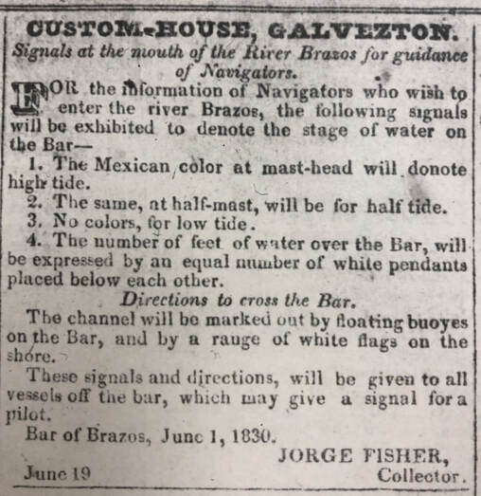

Note: If readers have suggestions for improvement of the transcription or translation, please feel free to contact the first-listed transcriber above.

